**LAB -3**

**TASK -4**

**CODE :**

using System;

using System.Collections.Generic;

using System.Linq;

using System.Text;

namespace oop8

{

class check

{

public int input()

{

int n;

char[] word=new char[100];

Console.WriteLine("Enter length of word : ");

n = int.Parse(Console.ReadLine());

Console.WriteLine("Enter any word :");

for (int i = 0; i < n ; i++)

{

word[i] = Convert.ToChar(Console.Read());

}

int vowel = 0;

for(int i=0 ; word[i]!='\0' ; i++)

{

if (word[i] == 'a' || word[i] == 'e' || word[i] == 'i' || word[i] == 'o' || word[i] == 'u')

{

vowel++;

}

}

return vowel;

}

static void Main(string[] args)

{

int a;

check dis = new check();

a=dis.input();

Console.WriteLine("vowels : {0}",a);

}

}

}

**OUTPUT:**

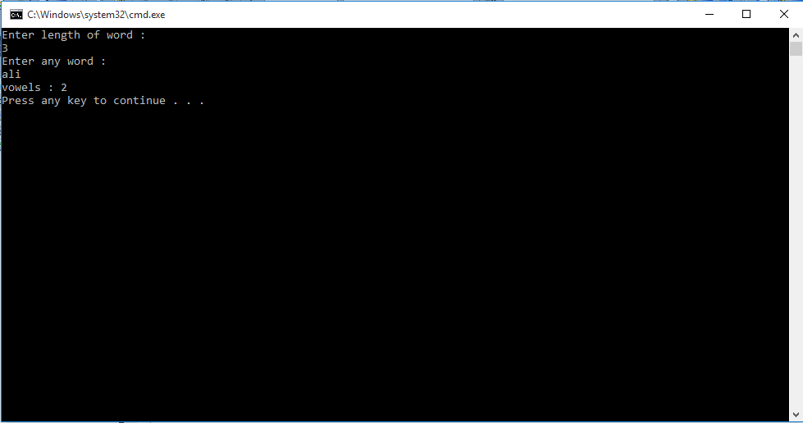

**TASK -5**

**CODE :**

using System;

using System.Collections.Generic;

using System.Linq;

using System.Text;

namespace oop9

{

class rectangle

{

public int lenght;

public int breath;

public int cal(int rec)

{

Console.WriteLine("Enter lenght and breath of rectangle");

lenght = Convert.ToInt32(Console.ReadLine());

breath = Convert.ToInt32(Console.ReadLine());

return rec = lenght * breath;

}

static void Main(string[] args)

{

int a=0;

rectangle st = new rectangle();

int rec=st.cal(a);

Console.WriteLine("Area of rectangle is : {0}",rec);

}

}

}

**OUTPUT:**

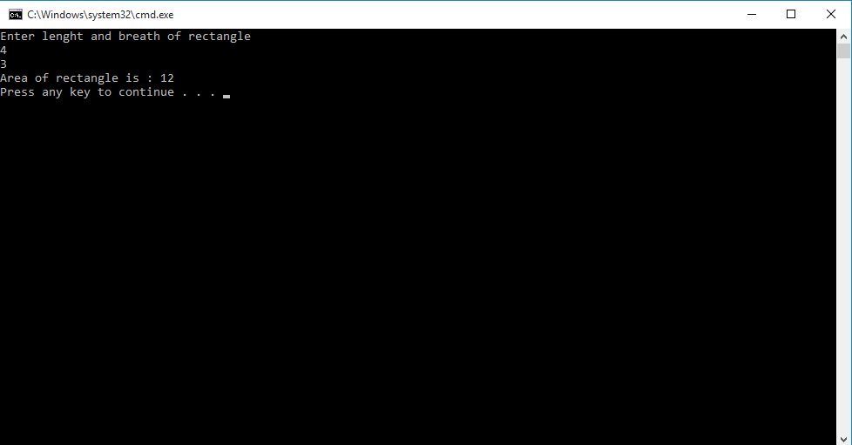

**TASK -6**

**CODE :**

using System;

using System.Collections.Generic;

using System.Linq;

using System.Text;

namespace oop10

{

class bank

{

protected int withdraw(int amount)

{

int withdraw;

Console.WriteLine("Enter amount you want to withdraw :");

withdraw = Convert.ToInt32(Console.ReadLine());

amount = amount - withdraw;

Console.WriteLine("Your withdraw amount : {0}",withdraw);

Console.WriteLine("Your Current balance : {0}" ,amount);

return amount;

}

protected int deposit(int amount)

{

int deposit;

Console.WriteLine("Enter amount you want to deposit");

deposit = Convert.ToInt32(Console.ReadLine());

amount = amount + deposit;

Console.WriteLine("Your withdraw amount : {0}", deposit);

Console.WriteLine("Your Current balance : {0}", amount);

return amount;

}

static void Main(string[] args)

{

string acc;

int amount;

int opt;

Console.WriteLine("Enter Account number :");

acc=Console.ReadLine();

Console.WriteLine("Enter amount in account :");

amount = Convert.ToInt32(Console.ReadLine());

Console.WriteLine("Enter options :");

Console.WriteLine("1 for deposit ");

Console.WriteLine("2 for withdraw");

Console.WriteLine("3 for check balance");

Console.WriteLine("4 for exit");

opt = Convert.ToInt32(Console.ReadLine());

bank draw = new bank();

if(opt==1)

{

draw.deposit(amount);

}

if (opt == 2)

{

draw.withdraw(amount);

}

if (opt == 3)

{ Console.WriteLine("Total balance : {0}" ,amount); }

if (opt == 4)

{

Environment.Exit(0);

}

Console.ReadKey();

}

}

}

**OUTPUT:**

